**ORGANISATION’S NAME AND LOCATION**

TELL US A SHORT INTRO ABOUT YOUR SCHOOL- This firm is just a guide so please feel free to adapt and change as much as you would like; including adding more photogarphs!!

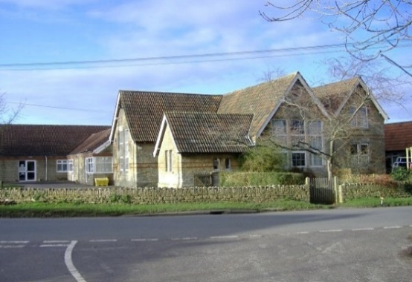

ECO FUNDRAISING

WHAT RECYCLING DO YOU DO?

**Can you give another school a piece of advice**

*Tag caption to help others*

TELL US ABOUT AN INITIATIVE YOU HAVE

A TIP FOR OTHER SCHOOLS

TELL US HOW YOU GOT STARTER